Лабораторна робота 8

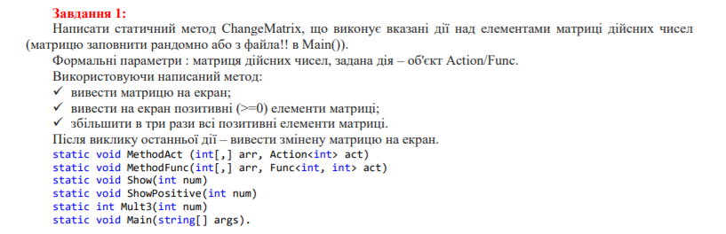

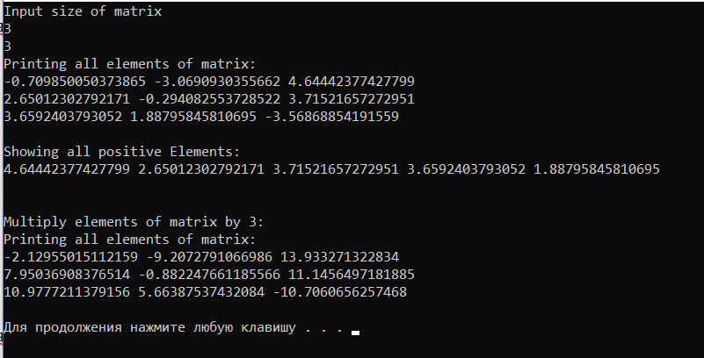

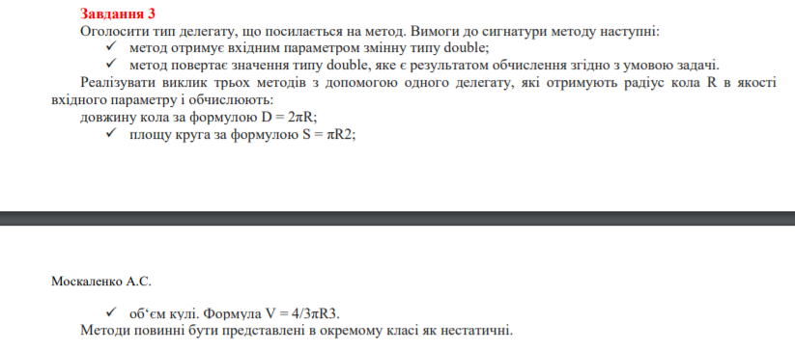

using System;

using System.Collections.Generic;

using System.Linq;

using System.Text;

using System.Threading.Tasks;

namespace lab8

{

public class Calculations

{

public double Square(double r)

{

return Math.PI * Math.Pow(r, 2);

}

public double Length(double r)

{

return 2 * Math.PI * r;

}

public double Volume(double r)

{

return (4.0 / 3) * Math.PI * Math.Pow(r, 3);

}

}

class Program

{

private delegate double Del(double r);

private static Calculations _calculations = new Calculations();

static void Main(string[] args)

{

var r = 0.0;

Console.WriteLine("Input R of circle");

r = double.Parse(Console.ReadLine());

if (r < 0) throw new ArgumentException();

Del del = _calculations.Volume;

Console.WriteLine($"Volume of circle is calculated. Result = {del(r)}");

del = _calculations.Square;

Console.WriteLine($"Square of circle is calculated. Result = {del(r)}");

del = _calculations.Length;

Console.WriteLine($"Lenght of circle is calculated. Result = {del(r)}");

}

}

}

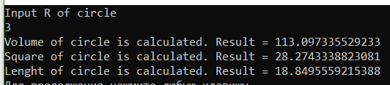

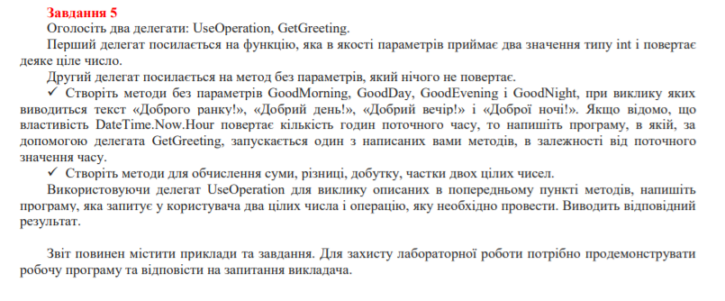

using System;

using System.Collections.Generic;

using System.Linq;

using System.Text;

using System.Threading.Tasks;

namespace lab8_5

{

public class Greeting

{

private delegate void Greetings();

private static Dictionary<int, Greetings> _dictionary = new Dictionary<int, Greetings>()

{

{3, GoodNight },

{9, GoodMorning},

{16, GoodDay},

{21, GoodEvening},

{24, GoodNight}

};

public static void GetGreetings()

{

Greetings greetings = _dictionary.First(item => DateTime.Now.Hour <= item.Key).Value;

greetings();

}

private static void GoodMorning()

{

Console.WriteLine("Good Morning!");

}

private static void GoodDay()

{

Console.WriteLine("Good Day!");

}

private static void GoodEvening()

{

Console.WriteLine("Good Evening!");

}

private static void GoodNight()

{

Console.WriteLine("Good Night!");

}

}

public class Program

{

public delegate double UseOperation(double a, double b);

public static Dictionary<string, UseOperation> _operations = new Dictionary<string, UseOperation>()

{

{"+", Plus},

{"-", Minus},

{"/", Divide} ,

{"*", Multiply}

};

public static void Main(string[] args)

{

Greeting.GetGreetings();

Console.WriteLine("Input the first and second number for operation");

var firstNumb = double.Parse(Console.ReadLine());

var secondNumb = double.Parse(Console.ReadLine());

Console.WriteLine("Input the operation you need: +,-,/,*");

var operation = Console.ReadLine();

double result = Operation(operation, firstNumb, secondNumb);

Console.WriteLine($"The result = {result}");

}

public static double Operation(string keyOperation, double a, double b)

{

return _operations[keyOperation](a, b);

}

public static double Plus(double a, double b)

{

return a + b;

}

public static double Minus(double a, double b)

{

return a - b;

}

public static double Multiply(double a, double b)

{

return a * b;

}

public static double Divide(double a, double b)

{

return a / b;

}

}

}

